SESSION 13

Q1) : 1. Decision Table — Coupon Validation
A coupon is valid only when all three conditions hold simultaneously. With 3 binary conditions, there are 2³ = 8 possible combinations:
Rule | Logged In | Cart Value > ₹500 | Coupon Expired | Action
R1 | Y | Y | N | Accept
R2 | Y | Y | Y | Reject
R3 | Y | N | N | Reject
R4 | Y | N | Y | Reject
R5 | N | Y | N | Reject
R6 | N | Y | Y | Reject
R7 | N | N | N | Reject
R8 | N | N | Y | Reject
Only R1 results in acceptance — the coupon is a strict AND condition, so any single failing condition forces a rejection.

Q2)
2. State Transition Diagram — Paytm Login Lockout
The system has four key states: Login screen, Account locked, OTP verification, and Logged in. Three consecutive wrong passwords trigger a lock, and only a successful OTP releases it.
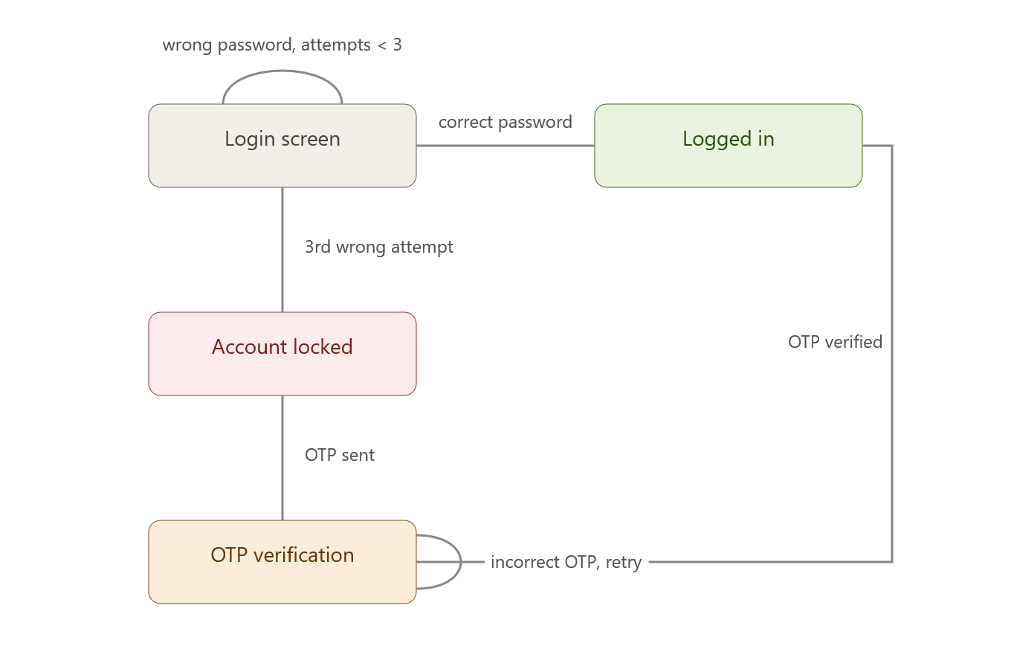

Q3) 3. Use Case Diagram — Zomato Order Flow
The base use case is Place order. Cancel order and Track order are modelled as «extend» relationships, since each only becomes available depending on the order's current state (before vs. after preparation).
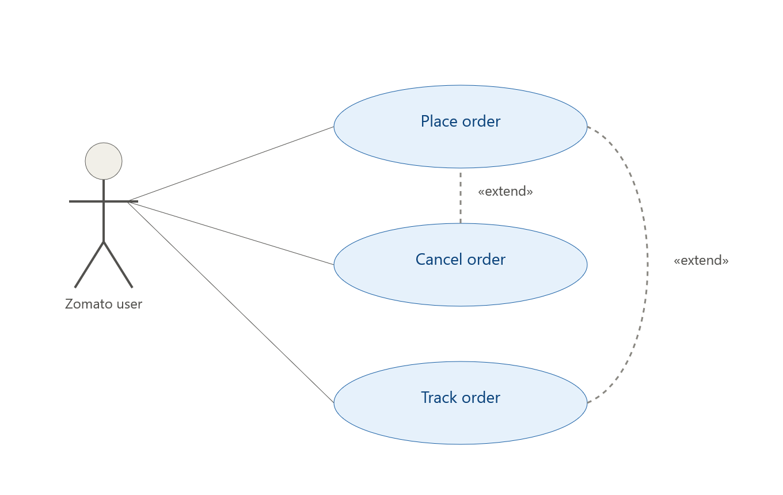

At least 3 test scenarios derived from this diagram:
- Successful order placement — user places an order and it moves to "preparing" without errors.
- Cancel before preparation — user cancels immediately after placing; system should accept the cancellation and stop the order.
- Cancel attempt after preparation has started — user tries to cancel once the kitchen has begun preparing; system should reject the cancellation (boundary/negative test on the extend condition).

Q4)
4. Modified Decision Table — Adding "Coupon Usage Count"
Adding a 4th condition — Usage Count < 2 (i.e., the coupon has been used fewer than 2 times by this user) — doubles the combinations from 8 to 16 (2⁴). Only the row where all four conditions are favorable results in acceptance; every row where any condition fails is a reject, including the new failure mode where all original conditions pass but the usage limit is exhausted.
Rule | Logged In | Cart > ₹500 | Coupon Not Expired | Usage Count < 2 | Action
R1 | Y | Y | Y | Y | Accept
R2 | Y | Y | Y | N | Reject — usage limit reached
R3 | Y | Y | N | Y | Reject
R4 | Y | Y | N | N | Reject
R5 | Y | N | Y | Y | Reject

